Project Documentation: TestSense AI

Unified QA & Test Intelligence Engine for Macy's Web & Mobile Applications

Executive Summary
TestSense AI is an intelligent, conversational QA bridge designed to streamline test automation, data management, and feature validation across Macy's web and mobile applications. It converts natural-language queries into instant backend API calls, shared test data lookups, visual feature knowledge searches, and cross-platform automation pipeline triggers.

Problem Statement
- Test Data Fragmentation & Invalidity: Test data (Web IDs, sandbox credit cards, addresses) remains trapped in static spreadsheets. Valid credentials created by one team are not systematically shared, forcing other teams to re-create data or work with stale records.
- Manual Setup Overhead: Executing setup routines such as funding loyalty accounts (M-Money, Star Money) or generating SUPC offer codes requires manual execution of Postman collections or CDE triggers, consuming 10–15 minutes per test cycle.
- Knowledge Gaps & Missed KT Calls: QA engineers often lack full visibility into new feature requirements or legacy app behaviors, especially if they miss live Knowledge Transfer (KT) sessions.
- Disjointed Automation Execution: Triggering cross-browser or mobile test suites across environments involves manual parameter configuration and complex pipeline setups.

Key Features & System Architecture

1. Instant Test Data Retrieval & Collaborative Data Sharing
- Converts plain-English queries into verified test data.
- Features a dynamic ingestion engine where any team can add new test data, Web IDs, or cards to the central repository, making it instantly accessible across the organization.

2. Automated Backend API Execution & Mocking
- Directly executes backend Postman collections and endpoints in real time:
  - Loyalty Account Funding: Funds M-Money/B-Money (/mbmoneycard/add) and Star Money rewards (/loyalty/setup).
  - Promotions & Offers: Configures campaigns and SUPC offer codes (/offer/addOffers, /campaign/setup).
  - Order API Mocking: Generates mocked order creation and checkout response payloads for isolated offline testing.
- Includes built-in parameter validation that prompts users automatically if mandatory inputs are missing.

3. Feature Knowledge Hub (Visual & Textual)
- Serves as a unified source of truth for legacy site behaviors and newly released features.
- Ingests feature specifications, acceptance criteria, edge-case guides, screenshots, and video walkthroughs.
- Enables QA engineers to query expected behaviors or generate test scenarios with complete visual context.

4. Automated Pipeline Triggering
- Executes natural-language commands to launch test suites on automation platforms like LambdaTest, while verifying available instances and requesting user confirmation prior to execution.
- Parses branch, channel, and environment parameters automatically.

System Architecture & Workflow Flowchart
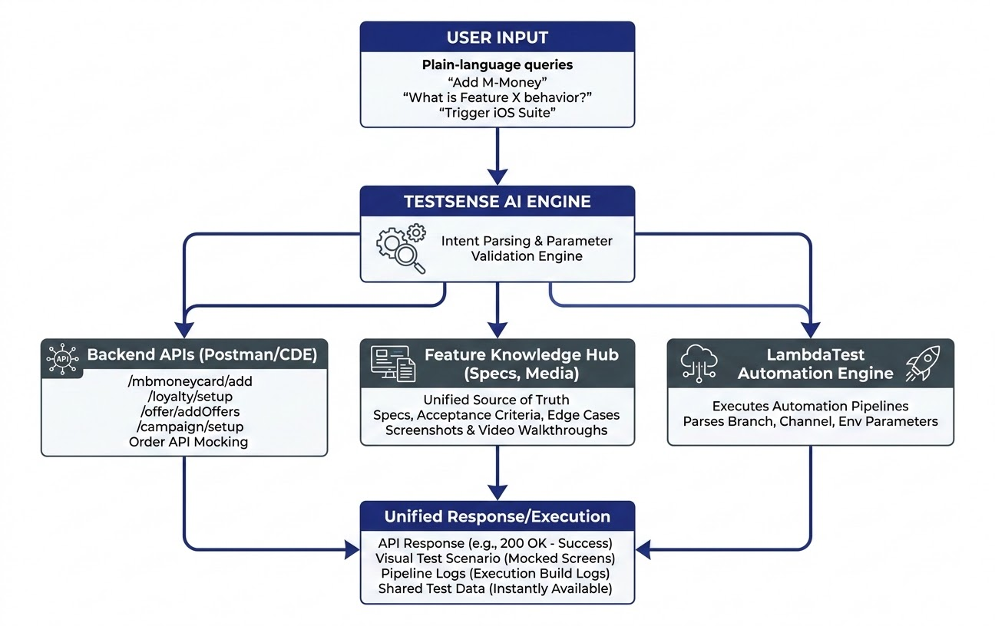

Business Impact & ROI

Metric | Before TestSense AI | With TestSense AI | Overall Impact
Test Data Prep Time | 10–15 Minutes | < 10 Seconds | 98% Time Reduction
Payload Setup Errors | Frequent Manual Errors | 0 Execution Errors | 100% Precision
Data Accessibility | Fragmented Spreadsheets | Single Shared Platform | Eliminated Data Silos
Feature Onboarding | Reliance on Live KT Calls | Instant Visual Search | Zero Delay on KT Gaps

User Interaction Examples
User Input | Agent Response & System Action
"Add M-Money to account testuser@macys.com" | Target Endpoint: POST /loyaltyautomation/mbmoneycard/add  Status: 200 OK - Success  Successfully funded account testuser@macys.com with $30 Macy's Money (4 cards added) in environment mcom-131.
"What is the expected behavior for the new Loyalty Star Money enhancement on iOS?" | Feature Summary: Star Money Rewards Display Enhancement v2.1  Acceptance Criteria:  - Active Star Rewards balance must render below the user greeting.  - Rewards expiring within 30 days display an orange warning badge.  Assets: Screenshot_IOS_Header.png, Walkthrough_Video_Loyalty.mp4
"Trigger pipeline for PDP using branch spatil on MCOM iOS in mcom-170" | Pipeline Analysis: Scanning environment mcom-170 for available instances... Found 2 idle VMs.  Parameters Identified: Feature: PDP | Branch: spatil | Channel: MCOM iOS | Env: mcom-170 | Test Classes: LoginTests, CheckoutFlow.  Action Required: Are you ready to trigger the build on the identified instances? (Yes/No)
"Save new BOPS Web ID 9876543 for category Home Goods" | Knowledge Base Updated: Added Web ID 9876543 under BOPS -> Home Goods. Entry is now available to all QA teams.

